**Question – 1 Define a function to check whether a given number is a Prime number or not.**

**Ans.**

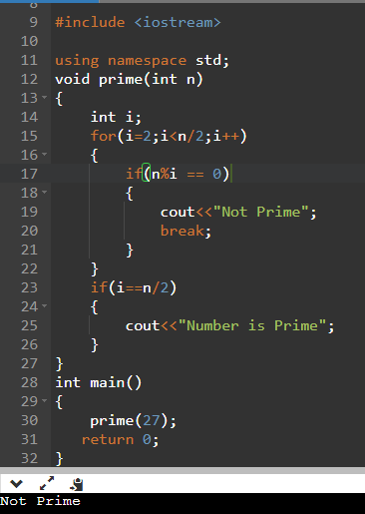

**Question – 2 Define a function to find the highest value digit in a given number.**

**Ans.**

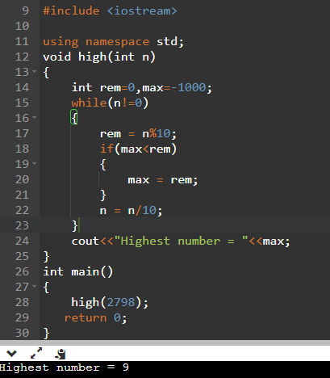

**Question – 3 Define a function to calculate x raised to the power y.**

**Ans.**

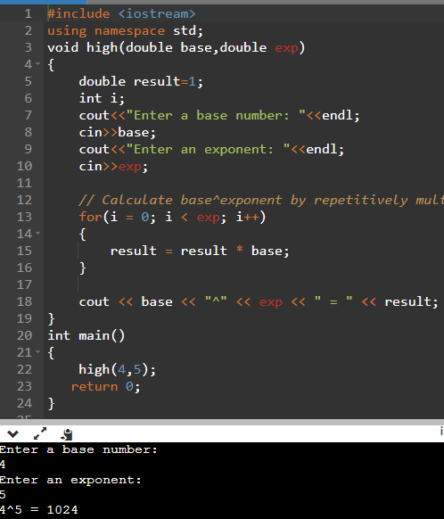

**Question – 4 Define a function to print Pascal Triangle up to N lines.**

**Ans.**

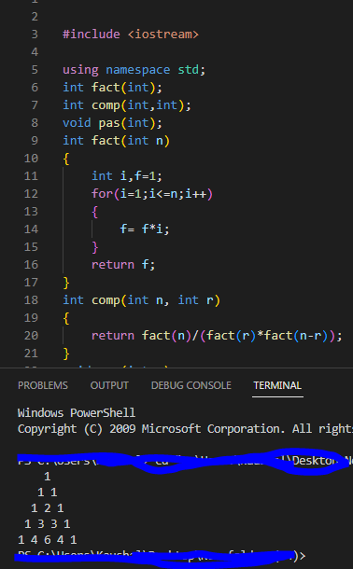

**Question – 5 Define a function to check whether a given number is a term in a Fibonacci series ornot.**

**Ans.**

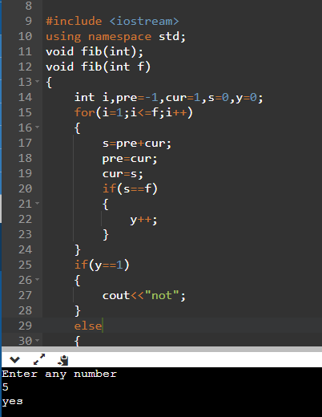

**Question – 6 Define a function to swap data of two int variables using call by reference.**

**Ans.**

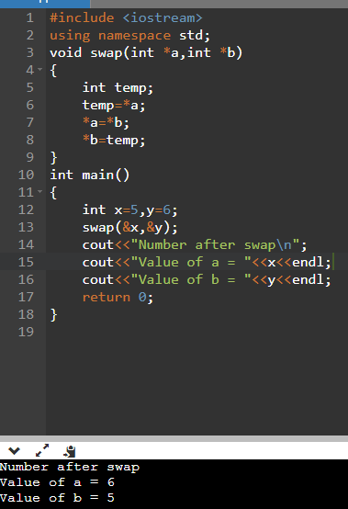

**Question – 7 Write a function using the default argument that is able to add 2 or 3 numbers.**

**Ans.**

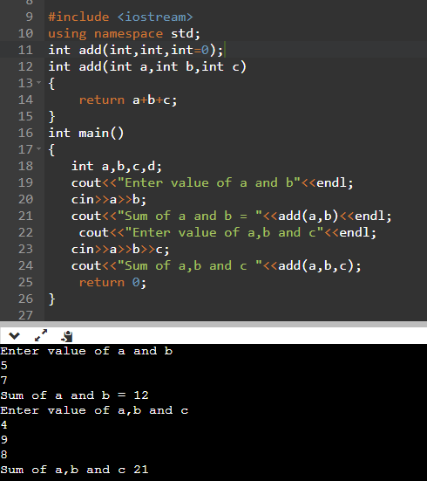

**Question – 8 Define overloaded functions to calculate area of circle, area of rectangle and area of triangle.**

**Ans.**

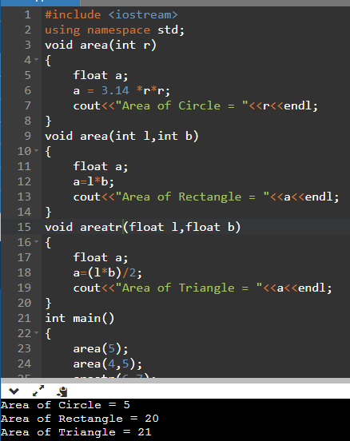

**Question – 9 Write functions using function overloading to find a maximum of two numbers and both the numbers can be integer or real.**

**Ans.**

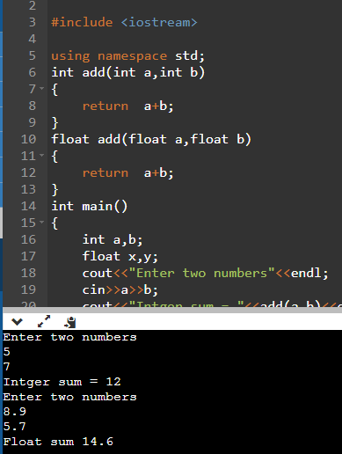

**Question – 10 Write functions using function overloading to add two numbers having different data types.**

**Ans.**

